A REPORT
on
Industrial Training - I
Submitted in Partial Fulfillment of the requirements For the Degree of
Diploma in CSE
By
Suraj Arya
CSE II Year, IV Semester
Enrollment No.: E22200835500049
Ambekeshwar Institute of Technology and Management (Lucknow)


Under the Supervision of
Academic Coordinator
Mr. Ashish Mishra
(Academic Coordinator)
AITM, Lucknow

Coordinator
Ms. Richa Mishra
(Head of Department)
AITM, Lucknow



to the
Faculty of Polytechnic
Board of Technical Education Uttar Pradesh (BTEUP), 2023-24



CERTIFICATE OF COMPILATION

This is to certify that the project report entitled “Industrial Training - I” is a Bonafide record of work done by Suraj Arya (Enrollment No.: E22200835500049), a student of Diploma in Computer Science and Engineering (CSE), during the academic year 2023-2024 in the Fourth Semester of the Second Year at Ambekeshwar Institute of Technology and Management, Lucknow.
This project report has been submitted in partial fulfilment of the requirements for the completion of the Diploma program

Coordinator
Ms. Richa Mishra
(Head of Department)
AITM, Lucknow

Academic Coordinator
Mr. Ashish Mishra
(Academic Coordinator)
AITM, Lucknow

EXTERNAL EXAMINER

DATE: ……………………

COPYRIGHT

Declaration by the Candidate

I hereby declare that the Industrial Training Report entitled “Web Development Using PHP” is an authentic record of my own work as requirements of Industrial Training during the period from 01/08/2024 to 15/09/2024 for the award of degree of Diploma in Computer Science & Engineering (CSE), Ambekeshwar Institute of Technology and Management, Lucknow, under the guidance of Mr. Kamal Kishor.

Place: Lucknow Student Name: Suraj Arya
Date: Enrollment No.: E22200835500049
Acknowledgement

I take this opportunity to express my heartfelt gratitude to all those who have supported and guided me throughout my Industrial Training, enabling me to successfully complete this report entitled "Industrial Training - I".
Firstly, I would like to extend my sincere thanks to the Ambekeshwar Institute of Technology and Management, Lucknow, for providing me with the opportunity to undertake this training, which has been a valuable learning experience.
I am profoundly grateful to Mr. Kamal Kishor, my esteemed supervisor, for his expert guidance, constant encouragement, and constructive suggestions during the course of this training. His valuable insights and feedback were instrumental in enriching my learning.
I also wish to express my gratitude to the faculty members of the Department of Computer Science and Engineering (Polytechnic) for their support and encouragement, which provided me with the necessary foundation to complete this training successfully.
Finally, I extend my deep appreciation to my family, friends, and colleagues, who have always been a source of motivation and inspiration throughout my academic journey. Their unwavering support has been a pillar of strength in accomplishing this project.
Thank you all for your guidance and encouragement.

Place: Lucknow Student Name: Suraj Arya
Date: Enrollment No.: E22200835500049
List of Figures

Figure No. 1 Entity Relation Diagram……………………………………………..07
Figure No. 2 Zero Level DFD ..…………………………………………….……...08
Figure No. 3 First Level DFD……………………………………………………...09

List of Abbreviations
ERD - Entity Relation Diagram
DFD - Data Flow Diagram
RAM - Random Access Memory
HDD - Hard Disk Drive
WAMP - Windows Apache MySQL PHP
PHP – Hypertext Preprocessor
XAMPP - Cross-Platform Apache MariaDB/MySQL PHP Perl

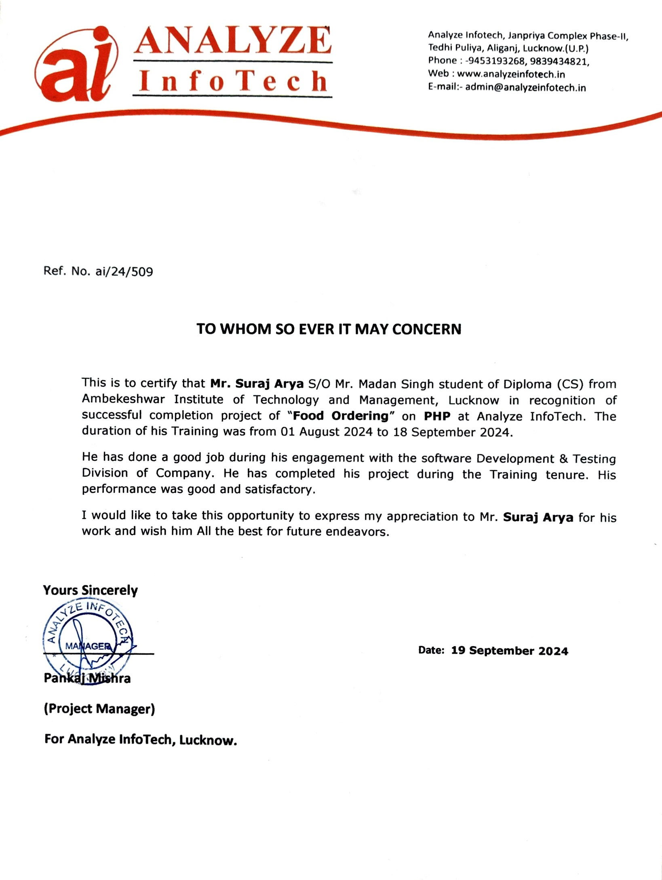

Table of Contents

S. No | Particulars | Page No.
1. | Introduction | 1
2. | Research and Analysis | 2-6
3. | Designing | 7-9
4. | Software and Hardware Requirements | 10
5. | Result | 11-16
6. | Conclusion | 17
7. | References | 18

- INTRODUCTION
Online Food Ordering System is a part of e-commerce. E-commerce or business through net means distributing, buying, selling, marketing, and servicing of products or services over electronic systems such as the Internet and other computer networks. Thus, if we own a restaurant, we need to upload menu online to attract potential customers.
The online food ordering system gives restaurants the ability to increase sales and expand their business by giving customers the facility to order food online. With an online restaurant menu ordering system, customers can place orders online 24 *7. Thus, it is a simple, fast and convenient food ordering system giving an edge over the competition at an affordable price.
Internet has seen a tremendous growth in terms of coverage and awareness. So, giving the business an online presence has become very crucial and important. With [Online Ordering System], we can set up we restaurant menu online and the customers can easily place order with a simple mouse click. Also, with a food menu online we can easily track the orders, maintain customer's database and improve the food delivery service. We can receive order through e-mails/ fax or directly view on internet.

1
1
- RESEARCH ANALYSIS
2.1 Problem Definition
At present there are many online food ordering systems that maintain their day-to-day transactions manually. These have a number of consumers, foods, staff as a result they need to track of all these client requirements. At this point FOOD ORDERING SYSTEM will play an important role in helping the admin to perform all these operation on a single click. This project will handle all the necessary data as well as every minute details of the campus and properly.
Purpose
The purpose of this document is to specify requirements and to give guidelines for the development of above said project. In particular it gives guidelines on how to prepare the above said project. The old system was suffering from a series of the drawbacks. Since whole system was to be maintained with hands the process of keeping, maintaining and retrieving the information was very tedious and lengthy. The records were never used to be in a systematic order as a result there used to be lot of difficulties in associating any particular transaction with a particular context. If any information was to be found it was required to go through different registers, documents there would never exist anything like report generation. There would be unnecessary consumption of time while entering records and retrieving the records. One more problem was that it was very difficult to find errors while entering records as a result if one record was entered then it was difficult to update these records.
Scope
As this is generic software it can be used by a wide variety of restaurants to automate the process of manually maintaining the records related to the subject of maintaining the entries and updating these records that too in a single click.
2.2 Objective
- Today’s world is computer world because most of work is doing with the help of computer. Dependency on computer is behind the few reasons. We cannot easily manage to store large number of data or information single handle. If we will be needing some information or data in urgency then we cannot manage in manually these works are very difficult if we cannot use computer.
- As the generic software it can be used by a wide verity of restaurants to automate the process of manually maintaining records related to the subject of maintain the records of each personnel in restaurants.
2
- This software is basically updating the manual work of systems. So that organization can manage their record in efficient and organize them.
2
- The main objective of the project is to develop software that facilitates the data storage, data maintenance and its retrieval for the restaurant in an igneous way.
- To store the records of the customers, the staff that has the privileges to access, modify and delete any record and finally the service, restaurants provide to its staff and customers.
- To save manpower.
- It will speed the processing of data and transaction.
- It will provide best security features such as provisions of passwords
- To develop a user-friendly system that requires minimal user training.

System Objective
Today’s world is computer world because most of work is doing with the help of computer. Dependency on computer is behind the few reasons. We cannot easily manage to store large number of data or information single handle. If we will be needing some information or data in urgency then we cannot manage in manually these works are very difficult if we cannot use computer.
System Context
This section clearly depicts the environment and boundaries of FOOD ORDERING SYSTEM and the entities with which it interacts. It helps us see how the system fits into the existing scheme of things. What the system will do by itself.
Functional Requirement
This Software must request Username and Password for access to data, only after authentication will allow access to the system. The Software must allow input of products data from administrator and secured access.
Non-Functional Requirement
In this Software Input error will be returned in red with appropriate message box. System should automatically update after every transaction.
2.3 Problem Specification
The definition of our problem lies in manual system and a fully automated system.
1. Manual System
The system is very time consuming and lazy. This system is more prone to error and sometimes the approach to various problems is unstructured.
3
2. Technical System
With the advent of latest technology if we do not update our system then our business result in losses gradually with time. The technical system contains the tools of latest trend i.e. computers, printers, FAX, Internet etc. the system with the technology are very fast, accurate, user friendly and reliable.
3
3. Need of FOOD ORDERING System
FOOD ORDERING SYSTEM software is very needy for various restaurants. This software helps them maintain day to day entries of the customers who are their client or those who desire to be, daily orders of the customers in computer.
4. The Proposed System
The proposed system helps them in many ways. It helps them do billing very easily. Account maintenance also becomes easier. They can keep track of their sales, stocks of the supplements and account details of their customers regarding their packages and many more. The software is provided with all the master entries to enter any new product, or customer or trainer to add or modify and delete.
5. Existing System
At present various Food ordering systems maintain their day-to-day transactions manually. These have thousands of products they need to track of all these products to check the stock, order date etc. To find the product is also another risky job and this also applies for in finding the details of the customer. So proper system is required. They need full pledged software to maintain their day-to-day transactions.

2.4 Problem Formulation
Introduction
Problem introduction or problem starting is the starting point of the software development activity. The software project is initiated by the client’s need. In the beginning, these needs are on the minds of various people in the client’s organization. The analyst has to identify the requirements by talking to the people and understanding to their needs. It goes without saying that an accurate and through understanding of software requirement are essentials to the success of software development effort. All further development like system analysis. System design and coding will depend on how accurate and well understood the requirements are poorly analysed and specified software will disappoint the user and will bring brief to the developer. No matter how well designed and well appearances are often deceiving. Chances of misinterpretation are very high; ambiguity is probable and communication gap between customer and developer is bound to bring confusions. Requirements understanding begin with a clear and concise heading stating in sentence the task to be performed. Then requirements are described in a technical manner precise statement.
4
2.5 Feasibility Study
All projects are feasible given unlimited resources and infinite time! Unfortunately, the development of computer-based system is more likely to be plagued by a scarcity of resources. It is both necessary and prudent to evaluate the feasibility of the project at the earliest possible time. Months or years of effort, Money loss and untold professional embarrassment can be averted I few better understand the project at its study time.
4
This type of study determines if an application can and should be developed. Once it has been determining that, application is feasible. After that analyst can go ahead and prepares the project specification, which finalizes project requirements. Feasibility studies are undertaken within tight time constraints.
- Technical Feasibility
- Operational Feasibility
- Economic Feasibility
- Legal Feasibility

- Technical Feasibility
As we know the technical feasibility is concerned with specifying equipment and software that will successfully satisfy the user requirement. The technical needs of the system may vary considerably, but might include:
- The facility to produce outputs of advertisements, shopping and mailing in a given time for ease of use.
- Response time under certain condition is minimal.
- Ability to process a certain volume of transaction at a particular speed.
- Facility to communicate data to distinct location.
- In examining the technical feasibility, configuration of the system is given more importance than the actual make of hardware. The configuration should give the complete picture about the system’s requirements- how many workstations are required, how these units are interconnected so that they could operate and communicate smoothly.

- Operational Feasibility
Proposed projects are beneficial only if they can be turned into information system that will meet the financial management requirements of the business/organization. This test of feasibility asks if the system will work when it developed and installed. Are there major barriers to implementation?
Some of the important questions that are useful to test the operational feasibility of a project are given below:
5
- Is there sufficient support for the project from the implementation? From user? If the present system is well liked and used to the extent that persons will not be able to see reasons for change, there may be resistance.
- Are current business methods acceptable to the user? If they are not, user may welcome a change that will bring about a more operational and useful system.
- Has the user been involved in the planning and development of the Project? If they are involved at the earliest stage of project development, the chances of resistance can be possibly reduced.
- Will the proposed system cause harm? Will it produce poorer result in any case or area?
- Will the performance of staff member fall down after implementation? Issue that Appears to be quite minor at the early stage can grow into major problem after Implementation.

- Economic Feasibility
Economic analysis is the most frequently used technique for evaluating the effectiveness of the proposed system. More commonly known as cost/benefits analysis, the procedure is to determine the benefits and savings that are expected from the purposed system and compared with costs.

If benefits outweigh cost, a decision is taken to design and implement the system. Otherwise, further justification or alternative of the proposed system will have to be made if it has a chance of being approved. This is an ongoing effort that improves in accuracy at each phase of the system life cycle. The analysis part also clears the doubt of economic problems which could be possible in developing the system. As already mentioned, that the company has to just pay the developed software cost and no other investment is needed at the time of implementation of the new system as the preliminary requirements already exist in the company.

- Legal Feasibility
In the legal feasibility is necessary to check that the software we are going to develop is legally correct which means that the ideas which we have taken for the proposed system will be legally implemented or not so, it is also an important step in feasibility study.

6
6

- DESIGNING
3.1 Entity Relation Diagrams
The Entity Relation Model or ERD is a data model or diagram for high-level description of conceptual data model, and it provides a graphical notation for representing such data models in the form of entity relationship diagrams. Such models are typically used in the first stage of Management information system design; they are used for example, to describe information needs and/ or the type of information that is to be stored in the Database during the requirement analysis. The data modelling technique, however, can be used to describe any ontology (i.e. an overview and classification of used term and their relationships) for a certain universe of discourse (i.e. area of interest).

In the case of design, a Management Information System that is based on a database, the conceptual data model is, a later stage (usually called logical design), mapped to a logical data model such as, relational data model; this is turn in mapped to a physical model during physical design. Note that sometimes, both of the phases are referred a “physical design”. There are number of conventions for entity-relation diagrams (ERDs). The classical notation is described in the remainder of this article, and mainly related to the conceptual modelling. There is a range of notation more typically employed in physical and logical database design.
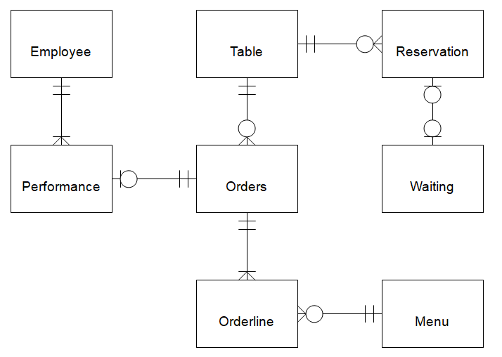

Fig. 1
7
7
3.2 Data Flow Diagram
The data flow diagram shows the flow of data within any system. It is an important tool for designing phase of software engineering. Larry Constantine first developed it. It represents graphical view of flow of data. It’s also known as BUBBLE CHART. The purpose of DFD is major transformation that will become in system design symbols used in DFD.

Context Level DFD
This level shows the overall context of the system and its operating environment and shows the whole system as just one process. Online book store is shown as one process in the context diagram; which is also known as zero level DFD, shown below. The context diagram plays important role in understanding the system and determining the boundaries. The main process can be broken into sub-processes and system can be studied with more detail; this is where 1st level DFD comes into play.

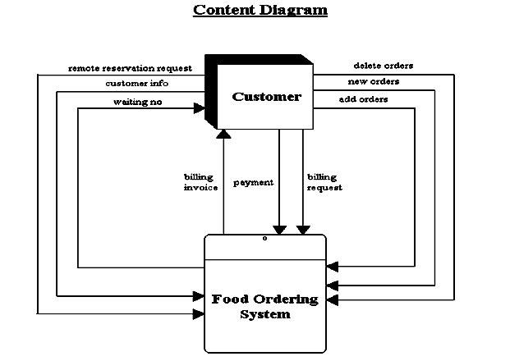
Fig.2.
First Level DFD
This level-1 shows all processes at the first level of numbering, data stores, external entities and the data flows between them. The purpose of this level is to show the major high-level processes of the system and their interrelation. A process model will have one, and only one, level-1 diagram. A level-1 diagram must be balanced with its parent context level diagram, i.e. there must be the same external entities and the same data flows, these can be broken down to more detail in the level-1
8
8
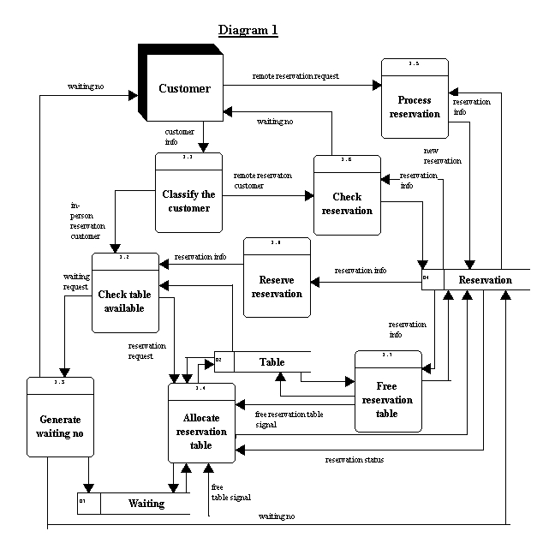 Fig.3.

9
9
- SOFTWARE & HARDWARE REQUIREMENT
4.1 Requirements Specifications
- Hardware Requirements
- Pentium IV Processor
- 512 MB RAM
- 40 GB HDD
- Colour Monitor
- Keyboard, Mouse

- Software Requirements
- WAMP/XAMPP
- Any text editor
4.2 MODULE DESCRIPTION
Login
The FOOD ORDERING SYSTEM first activates the login page. Here the user enters USER NAME AND PASSWORD and the system starts authentication process in which the USER NAME AND PASSWORD is matched with the existing USER NAME AND PASSWORD in the database. If the password matches then it is allowed to the main page else it warns the user for invalid USER NAME AND PASSWORD.
After the successful authentication the system activated menus. The activity log also prepared for failure and security There are two types of users using this software i.e., admin, student, faculties and staff.

Restaurants
This module has software configuration that admin and customers can access this module. Here admin performs certain operations like adding new restaurants’ details. In this admin assigns tasks to employee according to their capabilities.

Orders
Orders are handled in this module by the admin when customer orders the food from home.

Employees
Employees are handled in this module.
10
10
- RESULT

5.1 Database

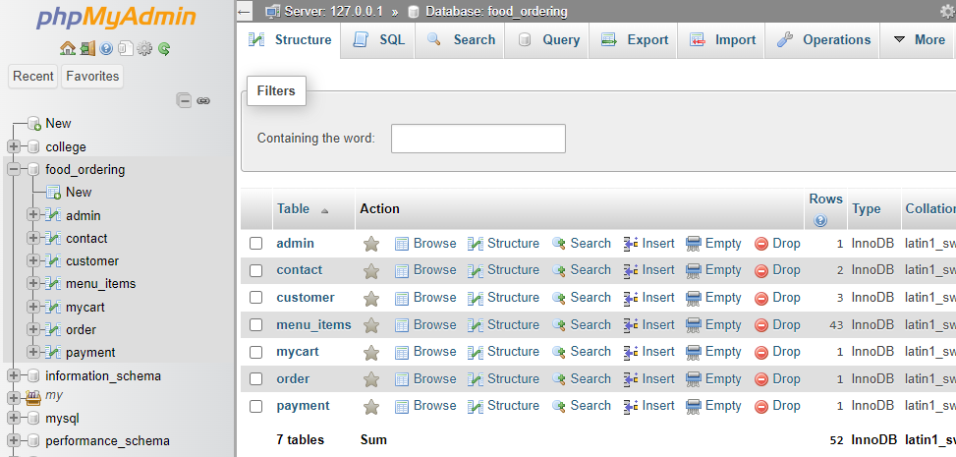

5.2 Front Page

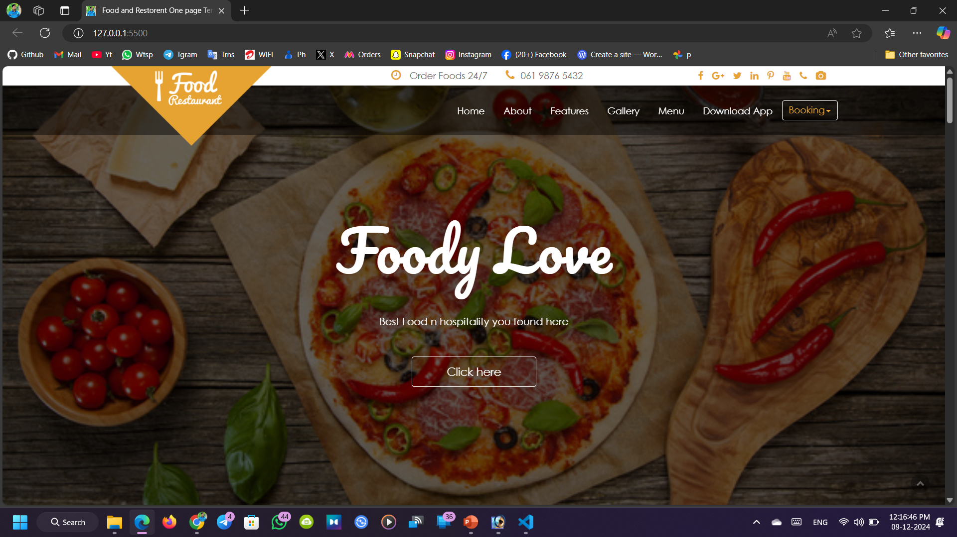

11
5.3 Signup Page
11

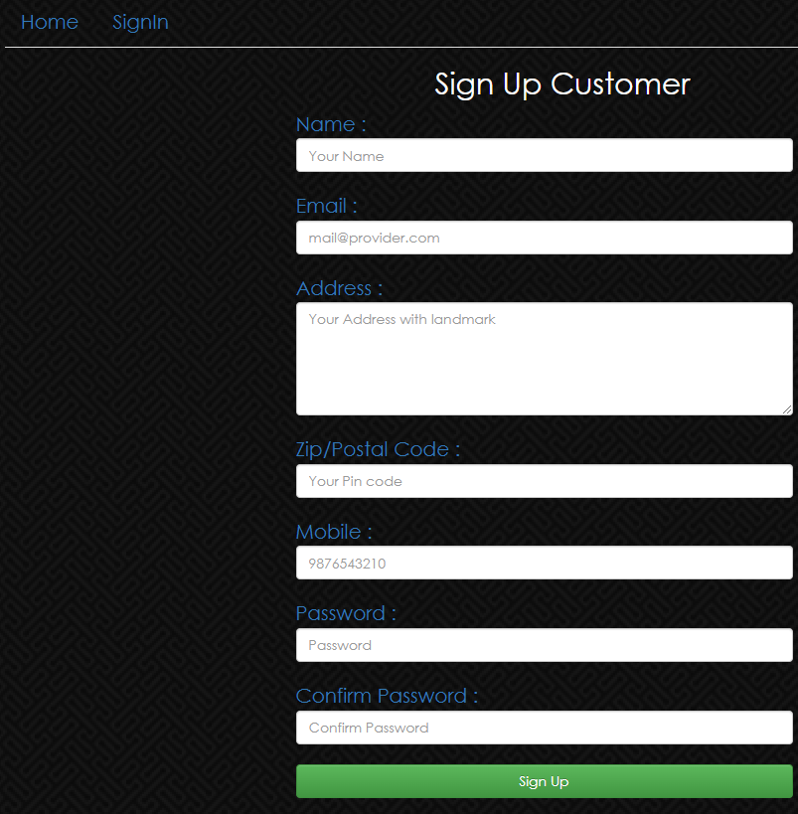

5.4 Sign in Page

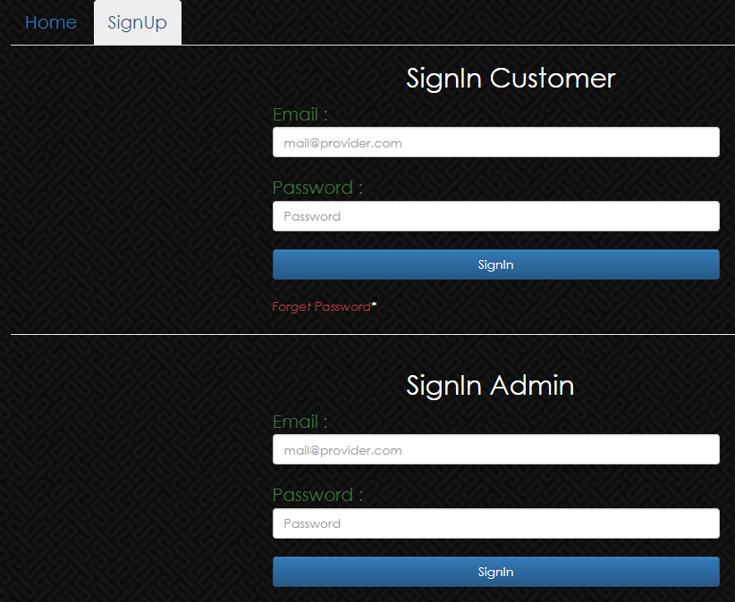
12
5.5 User Page

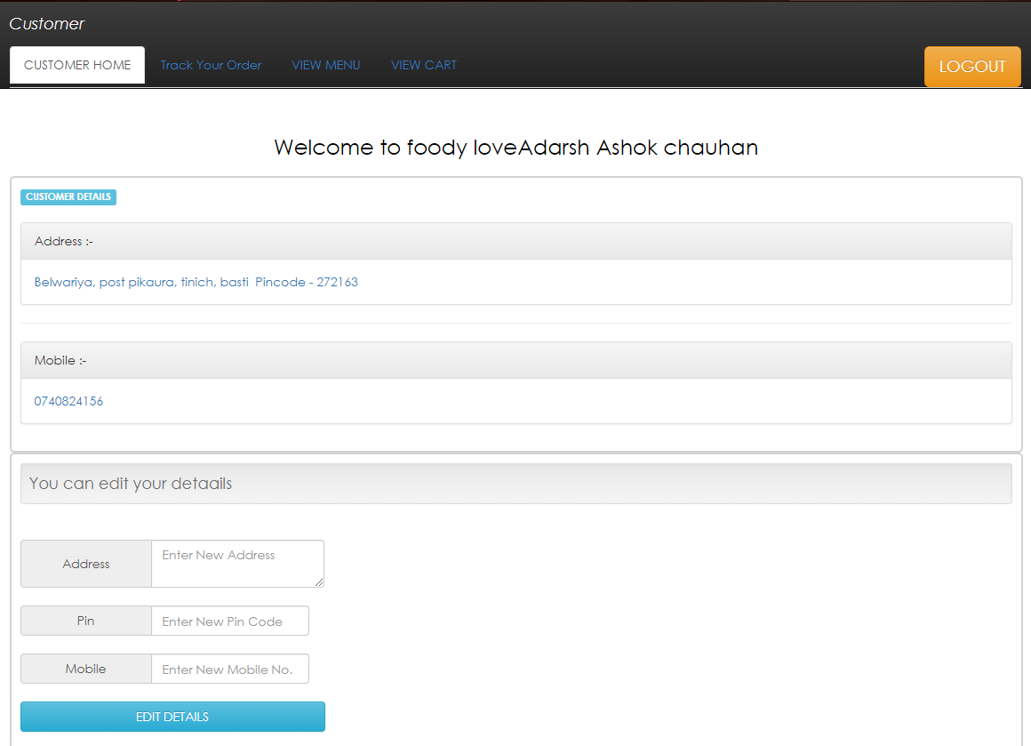
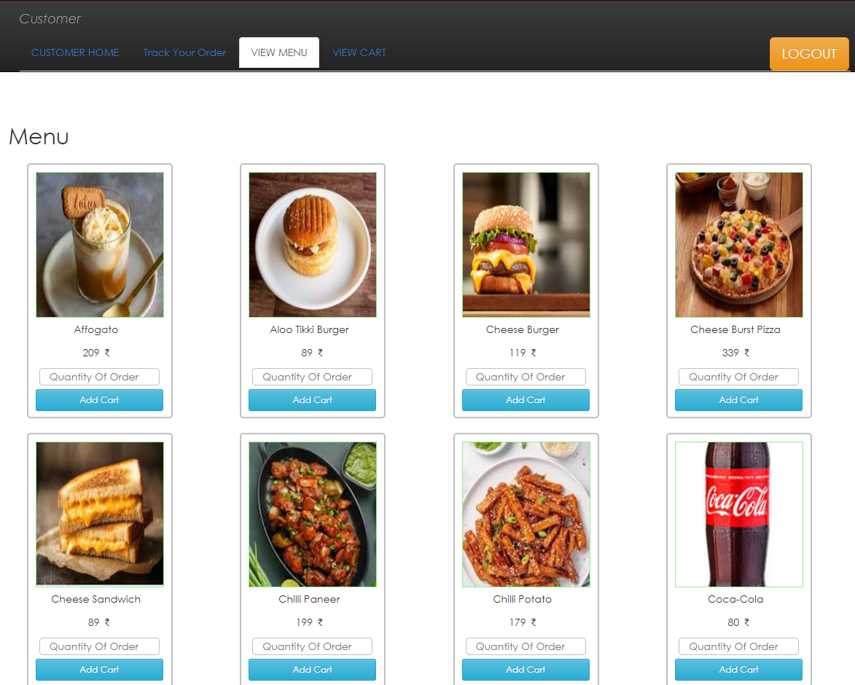
13
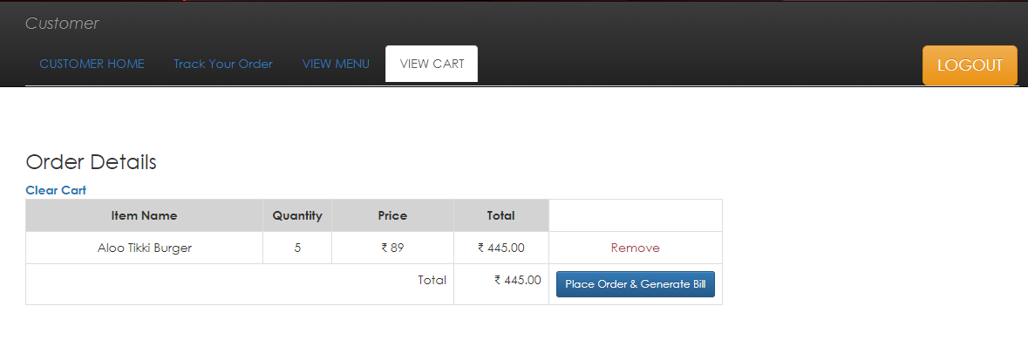

5.6 Admin Page

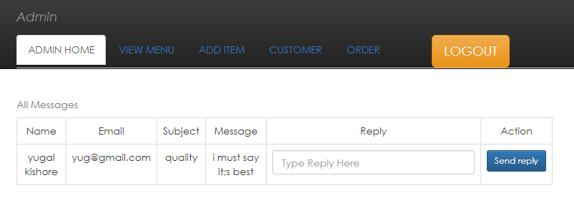
14
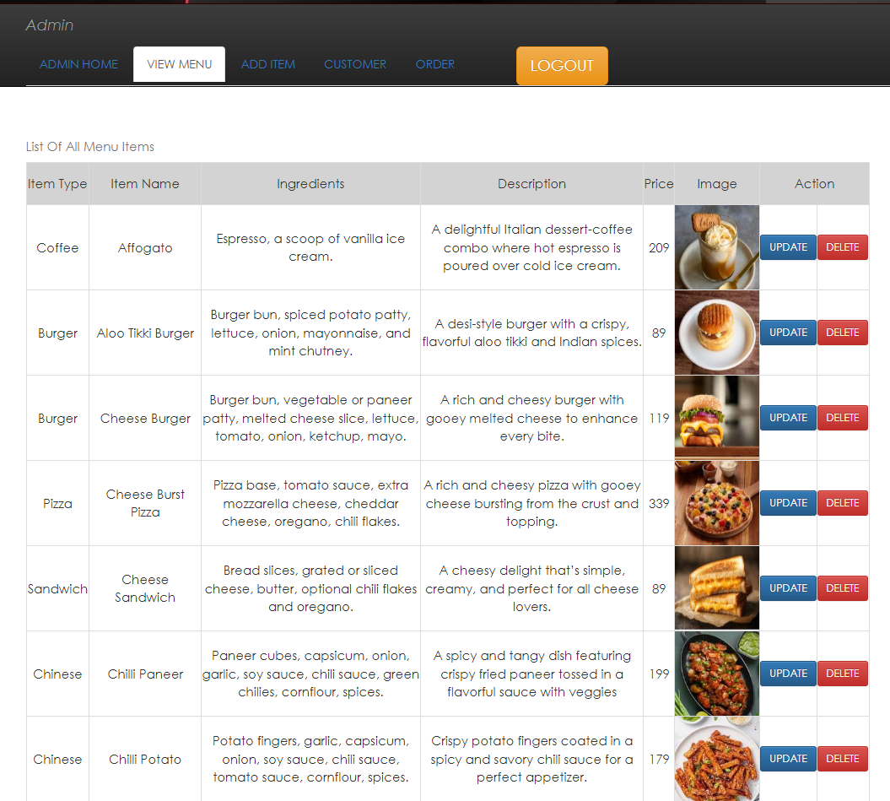

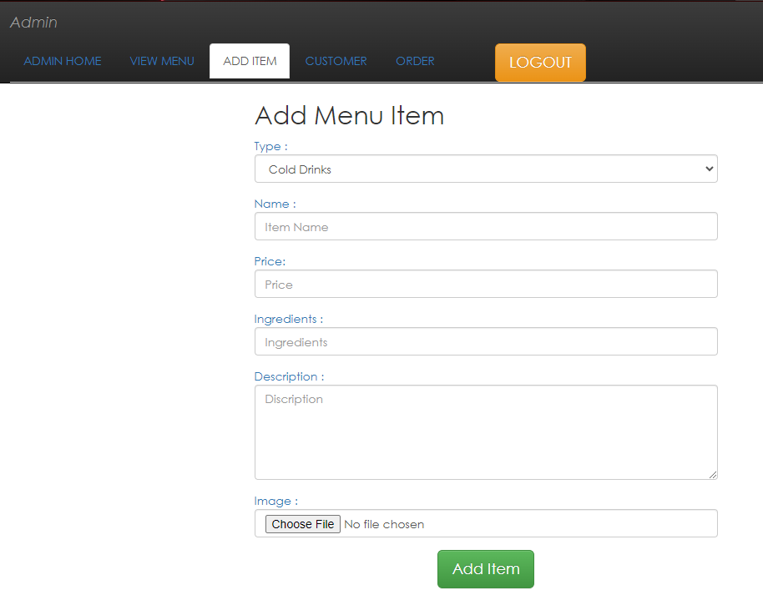
15
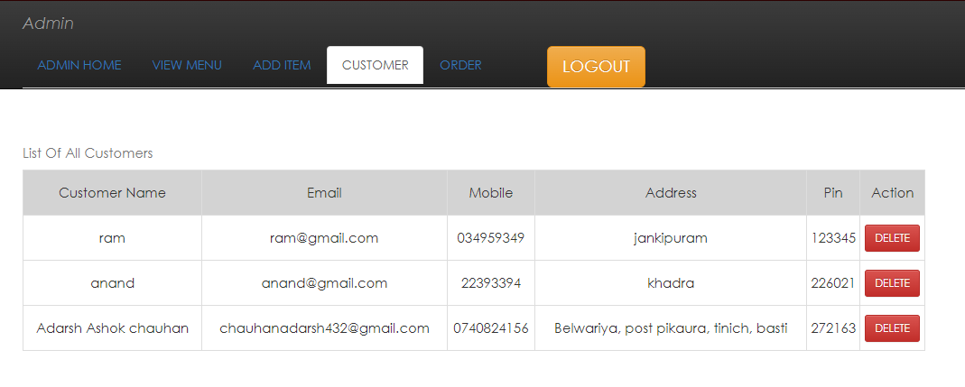
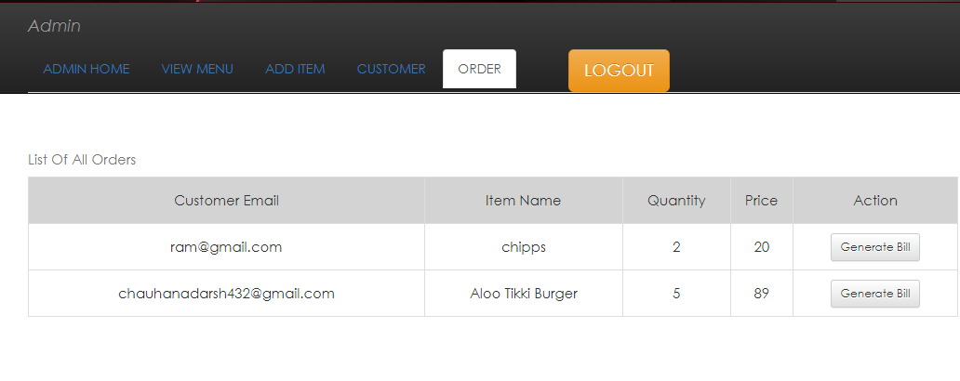
16
- CONCLUSION & FUTURE SCOPE
6.1 Conclusion of The Project
After completion of the training the students will be ready to face the challenges of the working Industry and Enhanced Competencies & Competitiveness in student's respective area of specialization. The author has worked on Web Designing & Development field under the arena of Computer Science & Engineering. The major works were Website Designing & Development based on HTML, CSS, PHP, JavaScript.
These types of Training Program Improves the Efficiency of working in a group as a Team and also improves Leadership quality among the Trainees.
Here, author gained the Experience & Knowledge that can be used for Suitable Jobs without delay after Completion of Study. With Experience, Knowledge & Skills acquired during this Industrial Training author will be better prepared for facing Professional Working World
6.2 Future Scope of The Project
The proposed system helps them in many ways. It helps them do billing very easily. Account maintenance also becomes easier. They can keep track of their purchases, sales, stocks and account details. The software is provided with all the master entries to enter any new product, or supplier, or to add or modify and delete.
As this is generic software it can be used by a wide variety of outlets (Retailers and Wholesalers) to automate the process of manually maintaining the records related to the subject of maintaining the stock and cash flows.
In future it can be modify, so that it can be done online. In order to meet this facility this is the major change which can be done in future regarding this project.

17
- References

Reference Books
- Head First PHP & MYSQL- By Lynn Beighley & Michael Morrison
- The Complete Reference- PHP- Steven Holzner
Reference websites
- www.scribed.com
- www.w3schools.com
- www.javatpoints.edu

18

